Project Update

There are some samples in your data (Order History) where the delivery time is a month or so (700 hours or more). For example, consider the first 10000 samples:

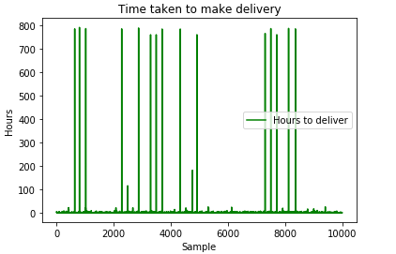

(Some bad samples are these : 800, 801, 2280, 2871, 3291, 3488, 3693, 4330, 4755, 4913, 7300, 7500, 7709, 8122, 8361 for example. You can check these in excel)

I have removed such abnormal samples, and kept only the samples where the delivery time is within 4 hours.

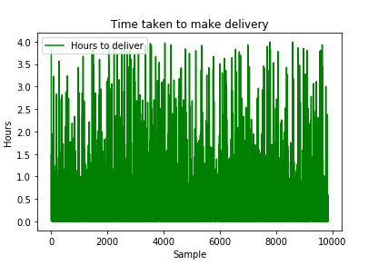

Now If we use 100 random samples for testing and remaining for training, we get a mean square error of 0.1 using SVM regression model.

